

Stamford University of Bangladesh

ER Diagram and Database

Report-4

Course title: Software Engineering

Course code: CSI 332

Project Name: Fun Learns

Submitted to:

Name: Ashfaq Ali Shafin

Designation: Lecturer

Stamford University Bangladesh

Submitted by:

Group Name: Tierce

|  |  |
| --- | --- |
| Nafisa Lubaba Rafisa | CSE 063 07432 |
| Naimul Islam | CSE 063 07444 |
| Rezwana Karim | CSE 063 07453 |

their study. Here, we will provide books according to the syllabus. Kids who are learning their first lesson or in nursery class will get much fun in their study. Students will get the solution of mathematics, experiments of science, history of a king or a rhyme in English according to their textbook but in an interesting way. Also, they will find things out of their textbook to increasing their knowledge. And it will be also easy for the parents to teach their children.

For example:

There are 74 litchies in a basket. There are 70 litchies in another basket. The litchies of the baskets put together and distributed equally among 8 persons. How many litchies does each person get?

The solution will,

I have 74 lichties

I have 70 lichties

together we have,

74 70 144

Dividing my 144 litchies among 8 people

Each will get,



18 18 18 18 18 18 18 18

Divison:144/8=18

Through this they will get the idea of the solution but not the solution.

“Learn with fun” is our main motive. Kids in these days are getting addicted in mobile, computer, internet more than books. But when will find their study with funny things they will enjoy it. So, we want kids to study while playing.

**Goals of the project:**

* Easy and free access for everyone.
* Making every subject’s interesting.
* Smart and systematic learning.
* Study and entertainment will combine, so kids will enjoy their study.
* Enhance the quality of learning.
* Meet the learning style or needs of students.
* New methods of learning will attract students.

**Feasibility:**

* Programming language: C#, Asp.net
* Database: SQL
* Operating system: Windows/ Linux

**Technical feasibility:**

* We are not hiring any developers so cost is decreasing.
* There won’t be any software cost, because we are using free or open source software.

**Economical feasibility:**

* As we are making things interesting according to the textbook so resources collecting cost will be zero.
* We want to make this a nonprofit project. So, every little we will do by ourselves. But if there any need the we will appoint system analyst and developer.

Data Flow Diagram (DFD):

**Activity List**

**ctivity List:**

**tivity List:**

Administration

Subjects

User management

* Keep user details.
* Record feedback reports.
* Insert/delete/update subject information.
* Upload learning materials.
* Record the test reports.
* Feedback of the tests.
* Confirm user’s registration.
* Record log-in information.

Main process: Fun Learn.

Sub Process: User management, Subjects, Administration.

Entity: Users, Admin.

Database: User_Info, Admin_Info, Subject_Info, Register_User, Feedback.

**Context level:**

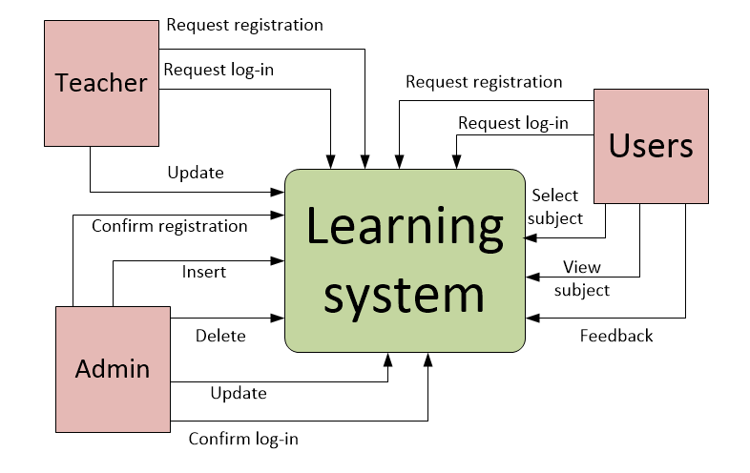

**Level-0:**

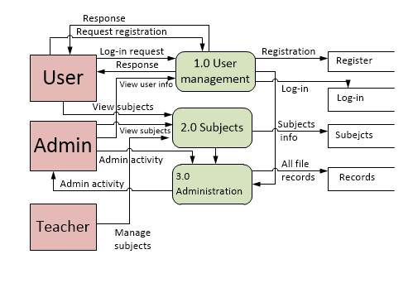

**DFD Level-1:**

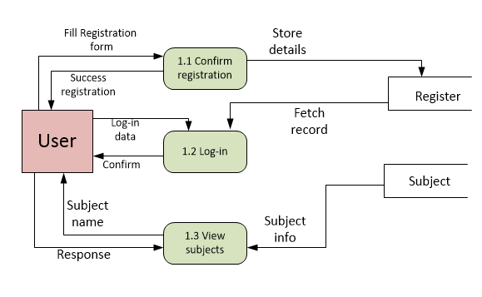

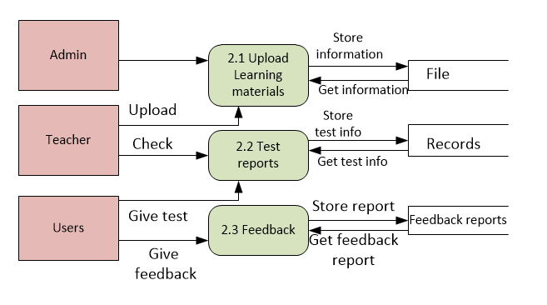

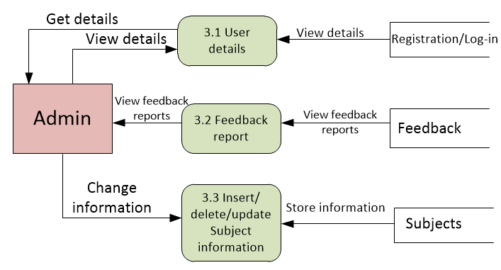

**Decomposition of DFD:**

|  |  |  |
| --- | --- | --- |
| **Context level** | **Level-0** | **Level-1** |
| Fun learn | 1.0 User management | 1.1 Confirm registration |
| 1.2 Log-in |
| 1.3 View subjects |
| 2.0 Subjects | 2.1 Upload learning materials |
| 2.2 Test reports |
| 2.3 Feedback |
| 3.0 Administration | 3.1 User detail |
| 3.2 Feedback report |
| 3.3 Insert/delete/update subject information |

E-R diagram:

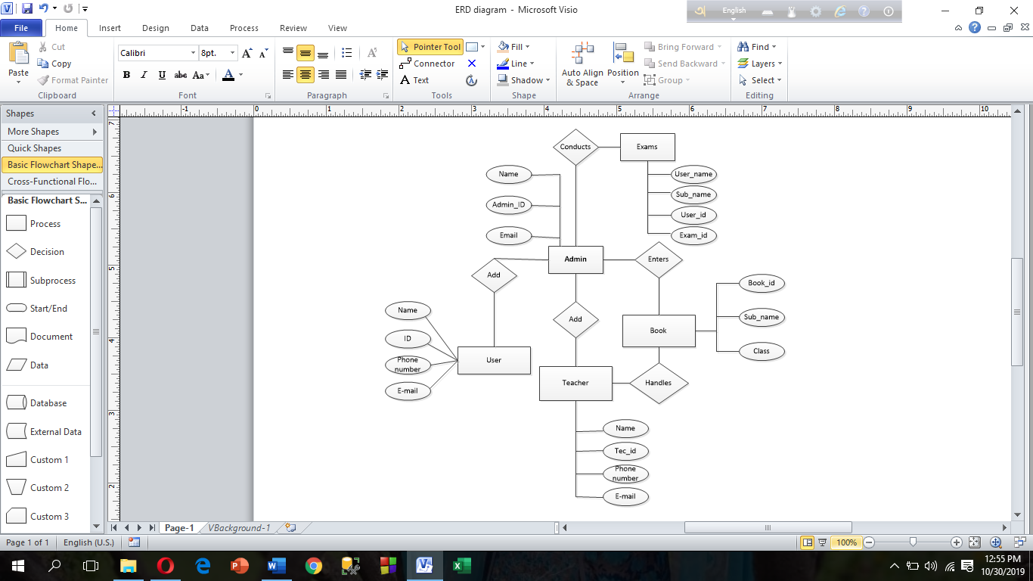

**Database tables, Attributes and Data type:**

|  |  |  |
| --- | --- | --- |
| **Table Name** | **Attribute** | **Data Type** |
| Admin | A_name | Varchar (50) |
| ADID | Varchar (15) (Primary key) |
| Email | Varchar (30) |
| TID | Varchar (15) (Foreign key) |
| UID | Varchar (15) (Foreign key) |
| BID | Varchar (10) (Foreign key) |
| EID | Varchar (10) (Foreign key) |
| Teacher | T_name | Varchar (50) |
| TID | Varchar (15) (Primary key) |
| Phone_number | Int (20) |
| Email | Varchar (30) |
| BID | Varchar (10) (Foreign key) |
| EID | Varchar (10) (Foreign key) |
| User | UID | Varchar (15) (Primary key) |
| User_name | Varchar (50) |
| Phone number | Int (20) |
| Email | Varchar (30) |
| Class | Int (10) |
| EID | Varchar (10) (Foreign key) |
| Book | BID | Varchar (10) (Primary key) |
| Sub_name | Varchar (20) |
| Class | Int (10) |
| Exam | User_name | Varchar (50) |
| Sub_name | Varchar (20) |

|  |  |  |
| --- | --- | --- |
|  | UID | Varchar (15) (Foreign key) |
| EID | Varchar (10) (Primary key) |

Benchmarking:

Conclusion:

We wanted to do this project so that students of play to primary level can learn their lessions easily. We wanted to keep them away from the extra burden of today’s educational war. We tried our best.